TEAM ID: PNT2022TMID10477

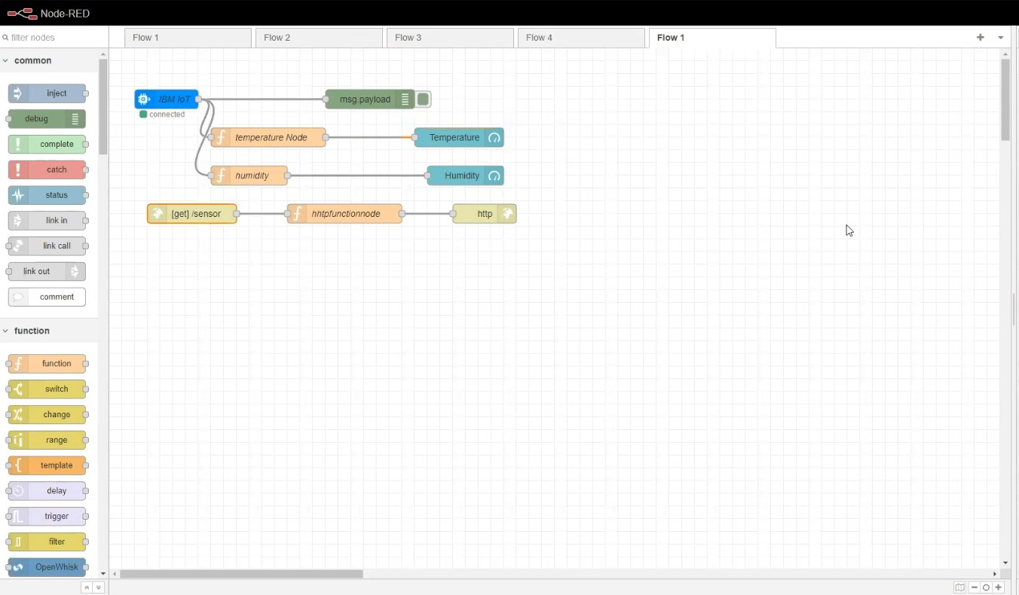

FIGURE 1

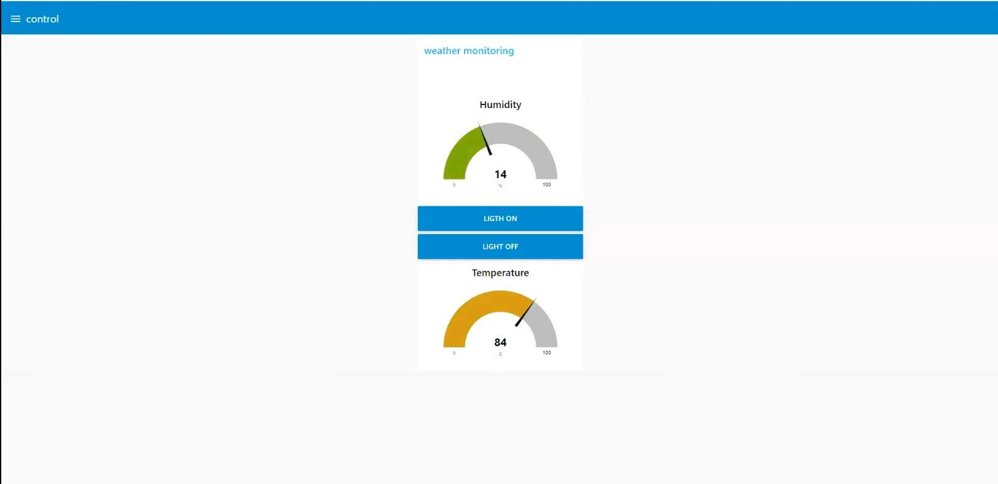

FIGURE 2